Hiyab Mengisteab

Statistic Data Mining Task 1

B. Purpose of the Data Analysis

B1. Research Question
What are the key housing features that significantly influence the sale price of a house, and to what extent can these features predict the final house price?

B2. Goal of the Analysis
The goal is to build a multiple linear regression model that can predict a house’s sale price (Price) using key property and neighborhood features. This model can be used by real estate firms and appraisers to estimate home values with more accuracy.

C. Data Preparation Process

C1. Variable Selection

Dependent Variable:
- Price: The final sale price of a house (continuous numeric)

Independent Variables:
Chosen based on domain knowledge and relevance to real estate pricing:
- SquareFootage (size is a primary driver of value)
- NumBathrooms (comfort and convenience)
- CrimeRate (inverse relationship to price)
- SchoolRating (good schools increase value)
- RenovationQuality (directly impacts buyer perception)
- LocalAmenities (desirable neighborhoods)
- DistanceToCityCenter (location premium)
- Garage

C2. Descriptive Statistics
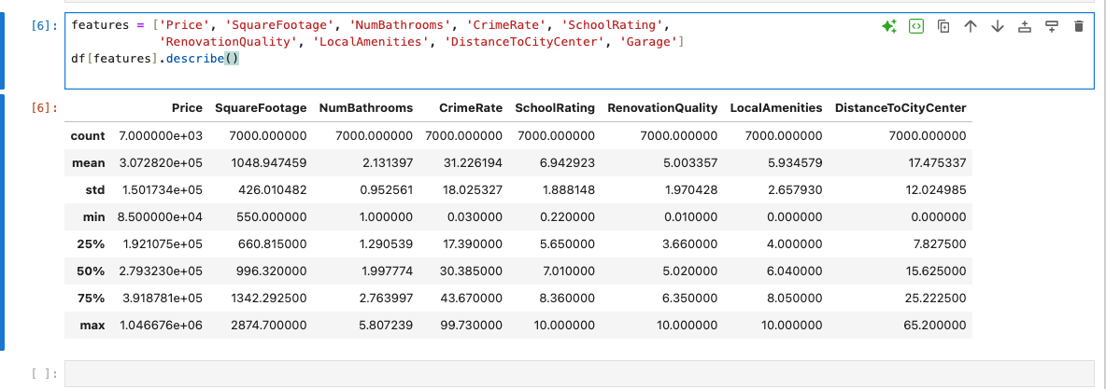

C3. Visualizations
- Univariate: Histograms plots for each variable
- Bivariate: Scatter plots with regression line for each independent variable vs. Price

Univariate
Price | 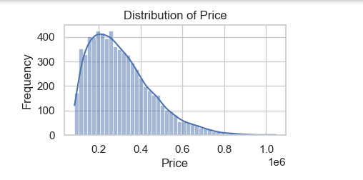
Square Footage | 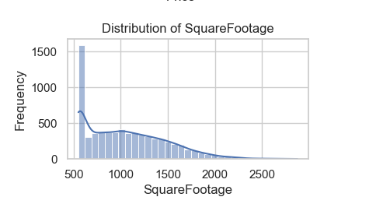
Number of Bathrooms | 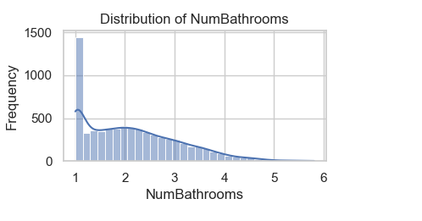
Crime Rate | 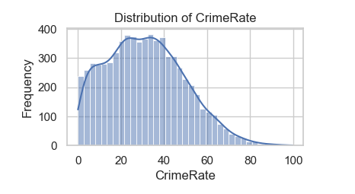
School Rating | 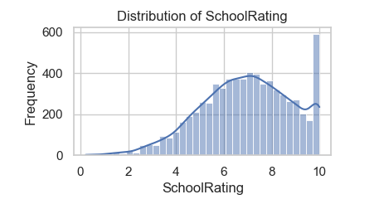
Renovation Quality | 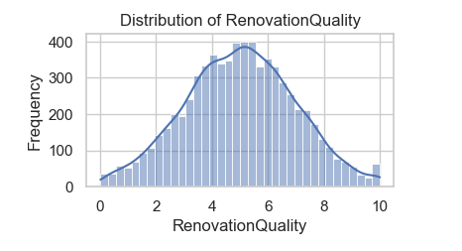
Local Amenities | 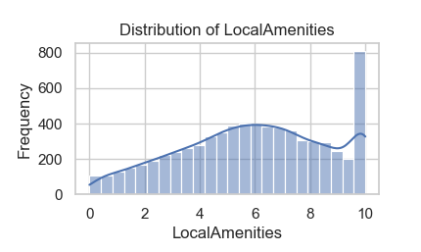
Distance to city center | 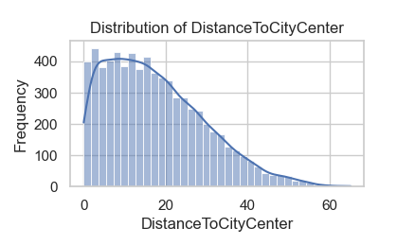
Garage availability | 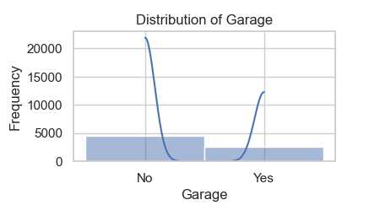

--
Bivariate
Square Footage Vs Price | 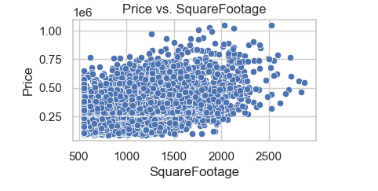
Number of Bathrooms Vs Price | 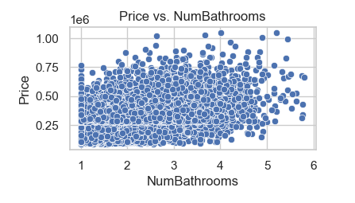
Crime Rate Vs Price | 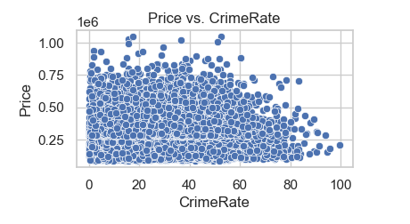
School Rating Vs Price | 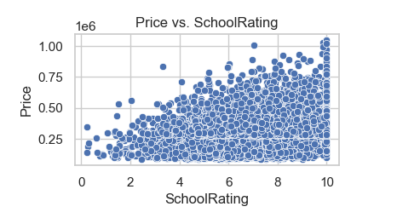
Renovation Quality Vs Price | 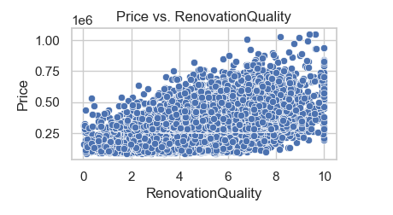
Local Amenities Vs Price | 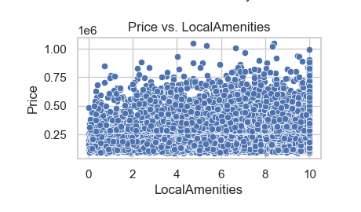
Distance to city center Vs Price | 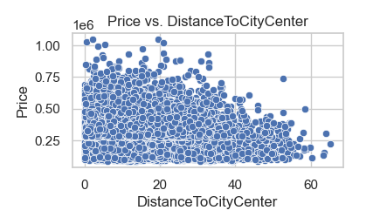
Garage availability Vs Price | 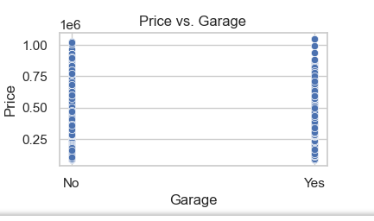

D. Data Analysis and Results

D1. Train-Test Split
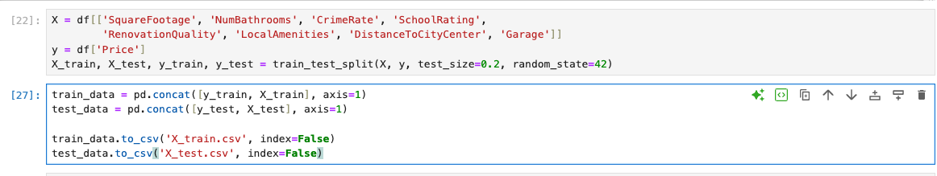

D2. Model Building & Optimization

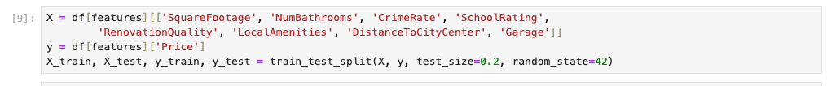

Linear Regression

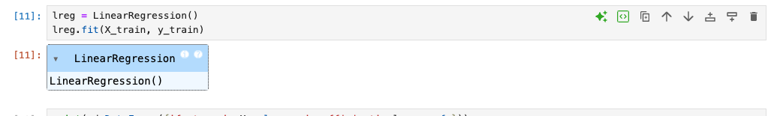

Coefficient

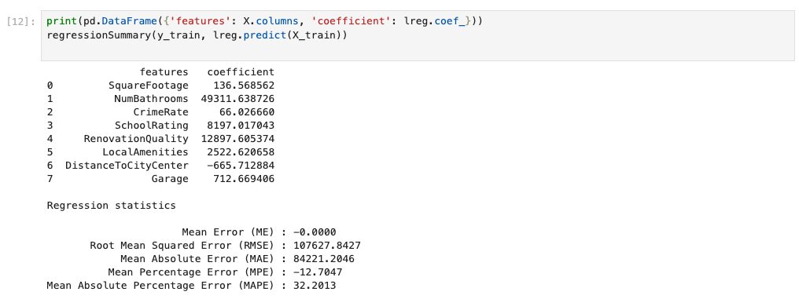

Verification:

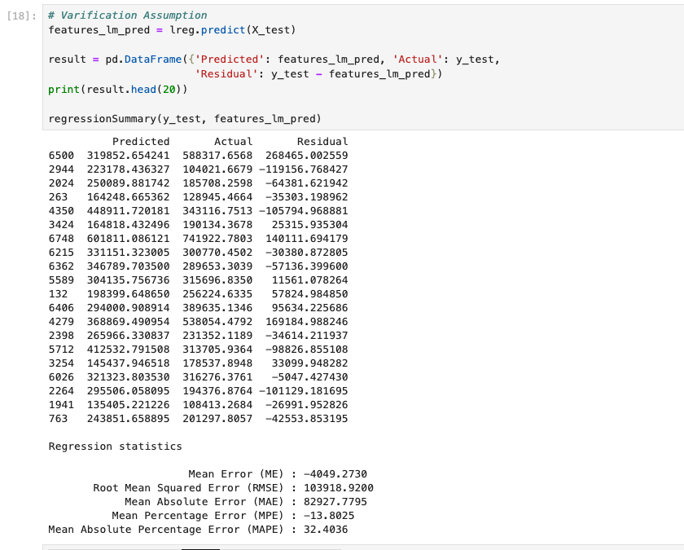

Backward Elimination

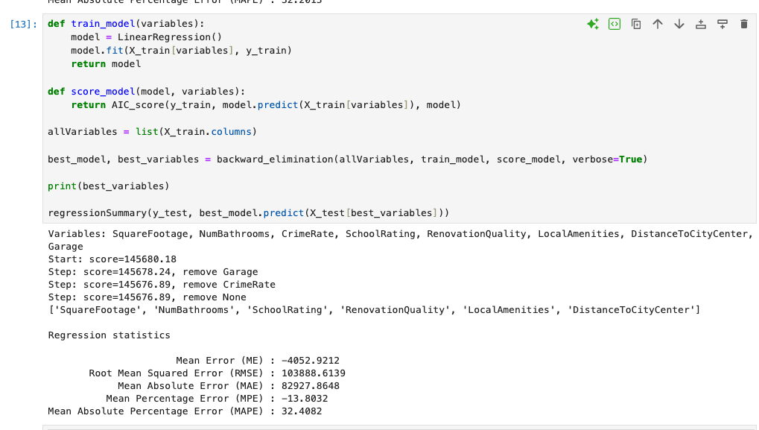

Summary Details :
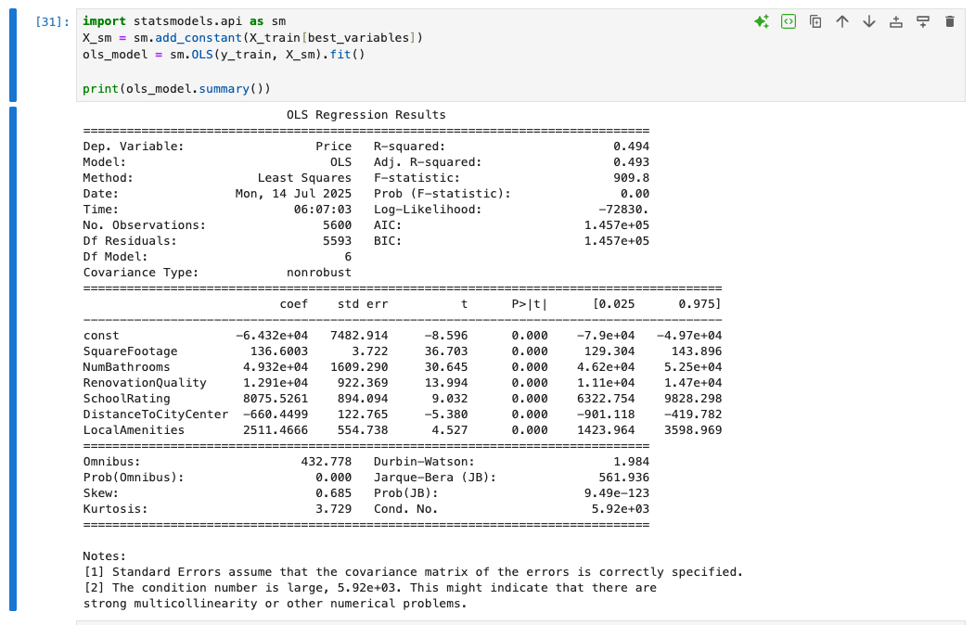
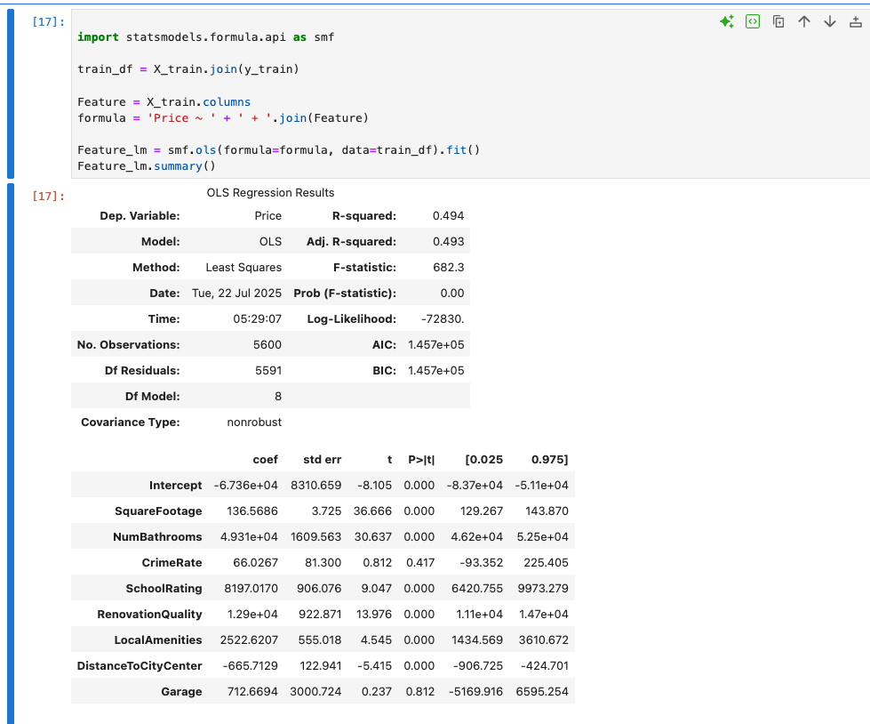

D3. MSE on Training Set
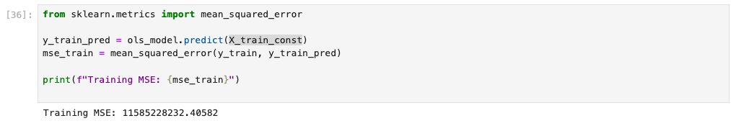

D4. Prediction on Test Set
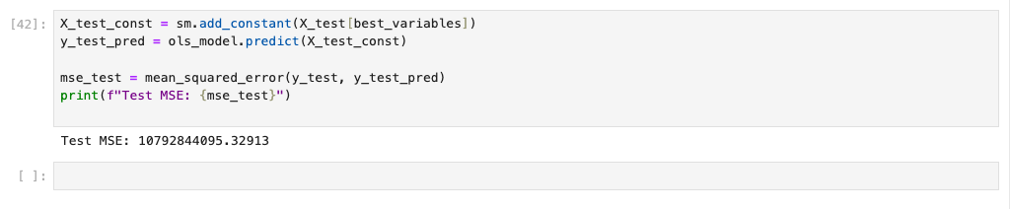

E. Summarize your data analysis by doing the following:
  - List the packages or libraries you have chosen for Python or R and justify how each item on the list supports the analysis.
Packages or libraries | Explain use
Pandas | Used for data manipulation and analysis using DataFrames.
scikit-learn (sklearn) | Used to build machine learning and model development.  - train_test_split: Splits data into training and testing sets.  - LinearRegression, Lasso, Ridge, LassoCV, BayesianRidge: Different types of regression models for prediction and analysis.
Seaborn and matplotlib | Plotting graphs and visualizations
NumPy | Numerical operations, handling arrays, math functions (e.g., mean, std, etc.).
dmba | A specialized library for business analytics for summary review and optimization.  - regressionSummary: Provides a concise summary of regression performance.  - exhaustive_search, backward_elimination, forward_selection, stepwise_selection: Feature selection techniques.
statsmodels.api | Provides functions for statistical modeling. Used for building OLS (Ordinary Least Squares) regression models, accessing model results, statistical tests, etc.
statsmodels.formula.api | Provide a formula-based interface to statsmodels. Used for creating statistical models using R-style formulas (e.g., y ~ x1 + x2).
sklearn.metrics | For scikit-learn (a machine learning library). Used for evaluating model performance by calculating the Mean Squared Error (MSE) between actual and predicted values.

  - Discuss the method used to optimize the model and justification for the approach.
  - To optimize the model, I applied the backward elimination method. This technique systematically removes variables that do not contribute significantly to predicting housing prices. Specifically, it starts with all available predictors and eliminates the one with the highest p-value at each step—indicating the least statistical significance—until only variables with meaningful contributions remain. This approach is effective because it helps simplify the model without sacrificing accuracy, improving interpretability while retaining key predictors. Based on the results, the final model retained the following variables, which had the greatest impact on house pricing:
    - SquareFootage
    - NumBathrooms
    - SchoolRating
    - RenovationQuality
    - LocalAmenities
    - DistanceToCityCenter
These predictors showed statistically significant relationships with housing prices, making them the most relevant features for the linear regression model.
  - Discuss the verification of assumptions used to create the optimized model.
  - To verify the assumptions and performance of the optimized linear regression model, I implemented a validation process that included comparing the predicted values, actual values, and residuals (calculated as the difference between predicted and actual values). This helped assess whether the model's predictions were reasonably accurate and whether the residuals behaved as expected under linear regression assumptions. Additionally, I used the regression summary output (e.g., from statsmodels) to review key statistical metrics such as the mean error, R-squared, adjusted R-squared, p-values, and confidence intervals. These metrics provided insight into the overall fit of the model and helped confirm that the retained predictors in the optimized model were statistically significant and contributed meaningfully to explaining the variance in housing prices. Garage and CrimeRate has higher P-value indicating less impact than the remaining attributes.
  - Provide the regression equation and discuss the coefficient estimates.
- The estimated multiple linear regression equation based on the provided coefficients is:
    - Price=−67,360+136.57⋅SquareFootage+49,310⋅NumBathrooms+66.03⋅CrimeRate+8197.02⋅SchoolRating+12,900⋅RenovationQuality+2522.62⋅LocalAmenities−665.71⋅DistanceToCityCenter+712.67⋅Garage
    - Each coefficient in the equation represents the expected change in house price for a one-unit increase in the corresponding feature keeping all things constant.
 | coef
Intercept | -6.736e+04
SquareFootage | 136.5686
NumBathrooms | 4.931e+04
CrimeRate | 66.0267
SchoolRating | 8197.0170
RenovationQuality | 1.29e+04
LocalAmenities | 2522.6207
DistanceToCityCenter | -665.7129
Garage | 712.6694

Variable | Unit | Impact on Price
SquareFootage | 1 square foot | For each additional square foot, the price increases by $136.57 keeping all things constant.
NumBathrooms | 1 full bathroom | Each additional bathroom increases the price by $49,310 keeping all things constant.
CrimeRate | 1 unit increase in crime index (scaled) | For each unit increase in crime rate, the price increases by $66.03 keeping all things constant.
SchoolRating | 1 point (e.g., rating scale 1–10) | Each additional point in school rating increases the price by $8,197.02 keeping all things constant.
RenovationQuality | 1 unit on a quality scale (e.g., 1–5) | A one-level improvement in renovation quality increases the price by $12,900 keeping all things constant.
LocalAmenities | 1 unit increase (e.g., count or index) | Each additional local amenity adds $2,522.62 to the price keeping all things constant.
DistanceToCityCenter | 1 unit distance (e.g., miles/km) | For each unit farther from the city center, the price decreases by $665.71 keeping all things constant.
Garage | 1 garage (e.g., binary: 1 = Yes, 0 = No) | Having a garage adds $712.67 to the house price keeping all things constant.

5. Discuss the model metrics by addressing each of the following:
• the R² and adjusted R² of the training set
    - R-squared (R²): 0.494: This means that approximately 49.4% of the variation in housing prices can be explained by the model’s independent variables (e.g., square footage, number of bathrooms, crime rate, etc.).
Even though this is not extremely high, this indicates a moderate level of explanatory power — the model captures nearly half of the patterns driving home prices.
    - Adjusted R-squared: 0.493: The Adjusted R² accounts for the number of predictors in the model and adjusts for the potential inflation of R² when more variables are added. A value of 0.493, which is very close to the R², suggests that most variables in the model contribute meaningful information. The model is not overfitted with unnecessary predictors.

• the comparison of the MSE for the training set to the MSE of the test set
    - Mean Squared Error (MSE) measures the average of the squares of the errors—that is, the average squared difference between the actual and predicted values. The Test MSE is slightly lower than the Training MSE. This is an encouraging sign because it shows that the model is not overfitting—it generalizes well to new data. The similarity in values suggests that the model performs consistently on both the training and test sets.
      - Training MSE (≈ 11.59 billion)
      - Test MSE (≈ 10.79 billion)
6. Discuss the results and implications of your prediction analysis.
  - The comparison between the training and test MSE values suggests that the model is both stable and reliable. The minimal difference between the two metrics indicates that the model generalizes well to unseen data and is not overfitted to the training set—an important characteristic of a well-optimized regression model.
  - Additionally, the backward elimination process helped identify the most impactful predictors of housing price. These key variables are:
    - SquareFootage
    - NumBathrooms
    - SchoolRating
    - RenovationQuality
    - LocalAmenities
    - DistanceToCityCenter
    - These features demonstrated the strongest influence on home prices, offering valuable insights into the primary drivers of value in the housing market. This information can be useful for both real estate investors and policymakers when evaluating property development or pricing strategies.
7. Recommend a course of action for the real-world organizational situation from part B1 based on your results and implications discussed in part E6.
    - Based on the objective outlined in Part B1, which was to identify the key housing features that significantly influence sale price, we successfully pinpointed the most impactful variables using the backward elimination method. The key features identified are:
      - SquareFootage
      - NumBathrooms
      - SchoolRating
      - RenovationQuality
      - LocalAmenities
      - DistanceToCityCenter
    - Furthermore, the model—trained and tested on selected attributes—was able to explain approximately 49.4% of the variation in housing prices, as indicated by the R-squared value. Combined with the model’s low mean percentage error, these insights provide a reliable foundation for real estate businesses to develop competitive and data-driven pricing strategies in the housing market.

Reference:
- External resources not used in this submission

